**Results from the dataset:**

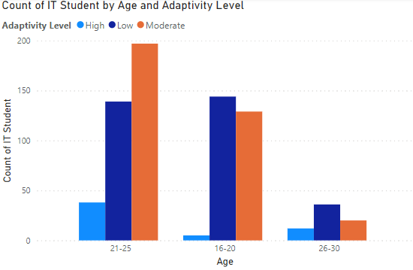

* Older students are more likely to have higher adaptivity level than younger students.
* The adaptivity of older students is higher maybe because they developed critical thinking and problem-solving because of more life experience, or maybe its due to higher motivation to succeed in their studies.

* Higher adaptivity levels by men.

* People with higher education level have higher adaptability levels than lower education which is positive correlation.
* This suggest that higher education levels may have more experience or they are more selective with the programs they select.

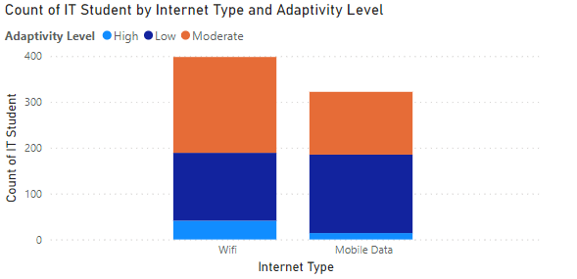

* Students uses the internet type that support their adaptability.
* Wi fi is more stable and reliable because it shows the adaptability levels are higher in the WIFI category.
* students with low adaptability levels tend to use mobile data more.

* higher level of education indicates to a higher level of adaptability and the same for moderate and low levels.
* Their experience made them more responsive to challenges in adapting new environments.

* We can see that using self LMS increases the adaptability a lot compared to those who don’t.
* Students are more comfortable with self LMS.
* Students who are drawn to self-learning maybe more adaptive to this system.

* High level of adaptability in university than college and school.
* The lowest level of adaptability was in college.
* The most moderate level of adaptability was in university.

**Results from the survey:**

1. 58% women, 42% men answered this survey.

1. 75% of the age range was from 16-20 and 25% from 21-25. And no responses from age 26-30.

1. 25% were very satisfied with the overall online learning experience, 33% were somewhat satisfied, 33% were neither satisfied nor dissatisfied, 0% somewhat dissatisfied, 8% were very dissatisfied.

1. aspects of the online learning platform they find most beneficial for their studies.

1. aspects of the online learning platform they find most challenging or frustrating.

1. their satisfaction with the availability and accessibility of course materials (e.g., lectures, readings, assignments) on the online platform. 25% very satisfied, 50% somewhat satisfied, 17% neither satisfied nor dissatisfied, 8% somewhat dissatisfied, 0% very dissatisfied.

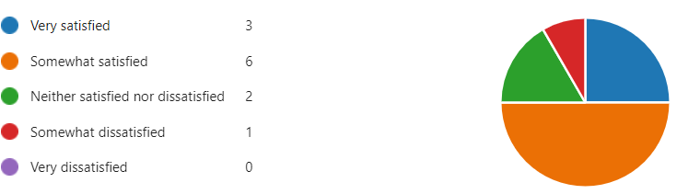

1. satisfaction with the communication and interaction with instructors and classmates in the online learning environment.

0% very satisfied, 33% somewhat satisfied, 25% neither satisfied nor dissatisfied, 33% somewhat dissatisfied, 8% very dissatisfied.

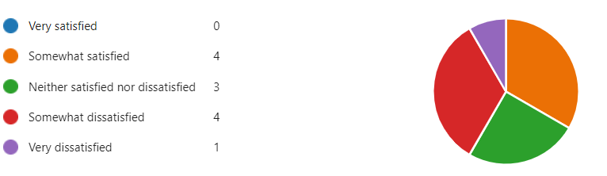

1. Do they feel adequately supported by the online learning platform in terms of technical assistance and troubleshooting?

25% yes, 25% no, 50% maybe.

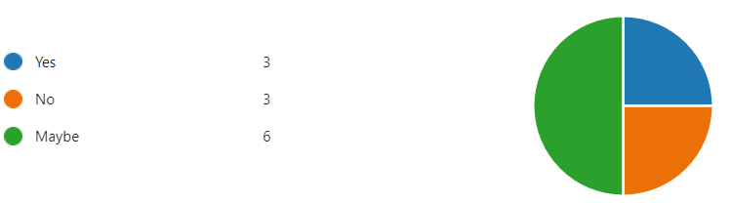

1. The satisfaction with the flexibility and convenience of online learning compared to traditional in-person classes.

17% very satisfied, 50% somewhat satisfied, 25% neither satisfied nor dissatisfied, 0% somewhat dissatisfied, 8% very dissatisfied.

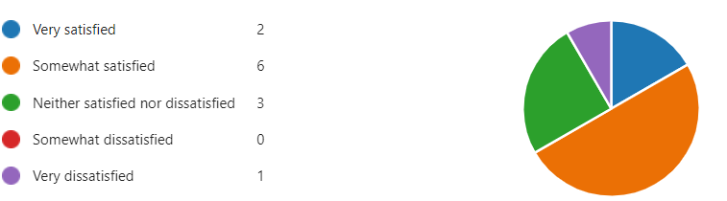

1. what difficulties they Have encountered accessing or navigating the online learning platform.

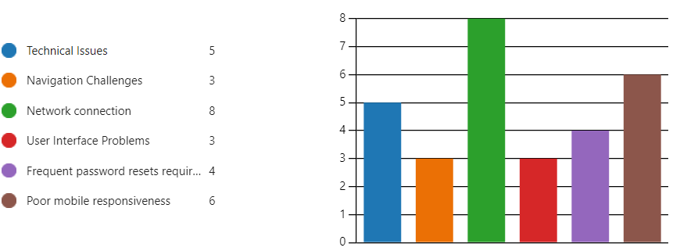

1. How satisfied they are with the clarity and organization of course instructions and materials provided on the online platform.

17% very satisfied, 33% somewhat satisfied, 25% neither satisfied nor dissatisfied, 17% somewhat dissatisfied, 8% very dissatisfied.

1. What additional features or improvements would they like to see implemented in the online learning platform to enhance their learning experience.

* Create online meetings to meet the instructors.
* Improving Interaction with instructors and colleagues.

1. How satisfied are they with the feedback and assessment mechanisms (e.g., quizzes, exams, grading) on the online platform.

8% very satisfied, 25% somewhat satisfied, 42% neither satisfied nor dissatisfied, 25% somewhat dissatisfied, 0% very dissatisfied.

1. How effectively do they think the online learning platform facilitates collaboration and group work with your peers.

0%very effectively, 33% somewhat effectively, 17% neither effectively nor ineffectively, 25% somewhat ineffectively, 25% very ineffectively.

1. Have they experienced any challenges or barriers to participation in online discussions or activities.

75% yes, 25% no.

1. How satisfied are they with the level of engagement and interactivity offered by the online learning platform.

0% very satisfied, 42% somewhat satisfied, 25% neither satisfied nor dissatisfied, 25% somewhat dissatisfied, 8%very dissatisfied.

